SOCIETY OF AMERICAN ARCHIVISTS
UNIVERSITY OF TEXAS CHAPTER

MINUTES

BOARD MEETING
Tuesday, February 7, 2011

Meeting called to order at 6:47pm by Carin Yavorcik

In Attendance:

Alison Clemens
Carin Yavorcik
Meg Eastwood
Rachel Appel
Ryder Kouba
Sarah Sokolow
Savannah Gignac
Wendy Hagenmaier
Carlos Duarte
Kristen Marx
Arcadia Falcone
Elliot Williams
Kristin Law
Megan Dirickson
Jessica Gauthier
Ellie Dickson
Maggie Bond

I. Congratulations to new board and introductions

The following SAA–UT members have been elected to serve as the board for 2012-2013:

PRESIDENT: Carlos Duarte
VICE PRESIDENT: Kristen Marx
TREASURER: Arcadia Falcone
EVENTS CHAIR: Elliot Williams
RECORDING SECRETARY: Becca Rasnic
SOCIAL MEDIA CHAIR: Kristin Law
MEMBERSHIP CHAIR: Megan Dirickson
ADVOCACY CHAIR: Jessica Gauthier
WEBMASTER: Meg Eastwood
ARCHIVIST: Ellie Dickson
MARKETING SECRETARY: Maggie Bond

Our outgoing President, Carin, passed her crown to the incoming President, Carlos. Carin will also be using the new online system at the UT student activities office to make the new board members the authorized representatives for SAA-UT.

Carin e-mailed all members of the new board a copy of the SAA-UT Board Handbook that was handed down from the 2010-2011 board (the outgoing board has also made updates). The manual contains sample treasury documents and sample press releases, etc.

II. First order of business for the new board

The Texas State Legislature mandates that all student groups must complete Safety Education training (the training is designed to discourage hazing in the Greek system). Three authorized representatives from the new SAA-UT board (and Carin is about the authorize the whole new board) must complete the following steps and then educate the membership about what they have learned.

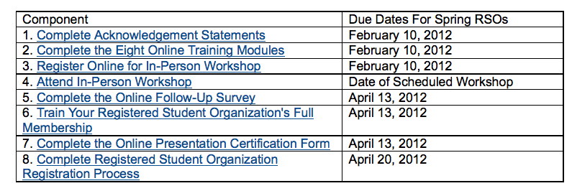

Please see http://deanofstudents.utexas.edu/sa/pses/rmprogram.php for more information.

As the timeline above shows, the first deadlines are this Friday, but Carin got an extension for new board until February 17th. Carin and Carlos have been corresponding about the safety education training but Carlos needs to be an authorized representative before he can start the training.

After the three board reps complete the modules and go to the training, they will get material to make a powerpoint presentation for the membership. The outgoing board made a video, then had a luncheon for the membership with free pizza where we showed the video. Then, we sent the link via e-mail to the rest of the membership, so they could verify that they received the information even if they couldn’t attend the luncheon.

III. Other upcoming events for the new board

Traditionally, SAA-UT has both a fall and a spring potluck. The outgoing board usually organizes the spring potluck as a place for people to meet the candidates for the new board, but we had to rush elections this year because of the safety education training deadlines. Dr. Trace has volunteered to host the spring potluck at her house later in February.

SAA-UT also traditionally takes a spring repository trip—last year we went to the National Archives in Fort Worth, and the spring before that they went to Dallas.

There are only a few SAA t-shirts left in stock, so the new board might want to order those soon.

The outgoing board submitted a proposal for the incoming board to present a poster at the SAA annual meeting (this year, the annual meeting is in San Diego!). Sarah Sokolow is the currently contact person for the poster proposal and she will forward the e-mail to the new board if the proposal gets approved. The outgoing board deliberately kept the proposal vague to give the new board leeway to create the poster they want to create.

In terms of Archives Week, the outgoing board started talking about theme and speakers in March, and we started trying to contact speakers in early April. The new board will need to book venues for Archives Week by the end of spring. A list of previous Archives Week themes can be found here (http://www.ischool.utexas.edu/~saa/archivesweek.html) if you need inspiration.

After the meeting, new board members should meet up with their outgoing counterparts so that they could trade off passwords and materials.

This meeting is adjourned, 6:59 pm.

